**Create data sources**

Search indexes can accept text from any source, provided it's submitted as a JSON document.  
  
[Indexers](https://learn.microsoft.com/en-us/azure/search/search-indexer-overview) are a feature that automates data import from supported data sources to extract searchable content in primary data stores. Indexers handle JSON serialization for you and most support some form of change and deletion detection. You can connect to a [variety of data sources](https://learn.microsoft.com/en-us/azure/search/search-data-sources-gallery), including [OneLake](https://learn.microsoft.com/en-us/azure/search/search-how-to-index-onelake-files), [Azure SQL Database](https://learn.microsoft.com/en-us/azure/search/search-how-to-index-sql-database), [Azure Cosmos DB](https://learn.microsoft.com/en-us/azure/search/search-howto-index-cosmosdb), or [Azure Blob storage](https://learn.microsoft.com/en-us/azure/search/search-howto-indexing-azure-blob-storage).

**Generally available data sources by Azure AI Search**

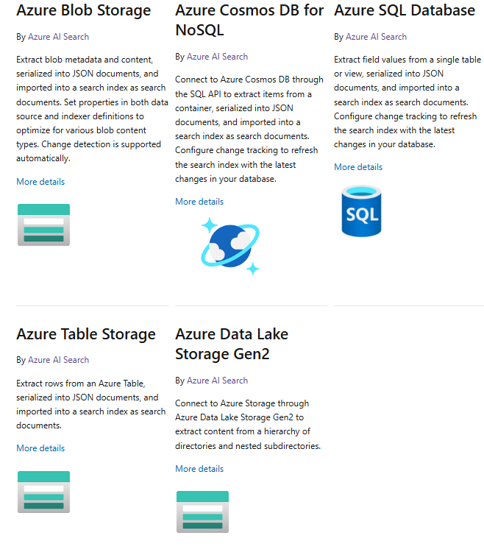

**Preview data sources by Azure AI Search**

**Data sources from third-party Partners**

Data source connectors are also provided by third-party Microsoft partners. These third-party Microsoft Partner data source connectors are implemented and supported by each partner and are not part of Azure AI Search built-in indexers.

<https://learn.microsoft.com/en-us/azure/search/search-data-sources-gallery>

1. Create Azure Storage account and container. Upload files to container.

1. Go to Azure AI search resource. Go to “Data sources” menu and click on “+ Add data source”.

1. Select “Azure Blob Storage” as Data source. Click on “Choose an existing connection”.

1. Select blob storage and container created.

1. Click on “Save” button.

